Art Style Guide

*By: Guy van der Meulen – GMD1B*

*For:*

*Donkey Kong 64 Themed Pinball Machine*

*6-11-2016*

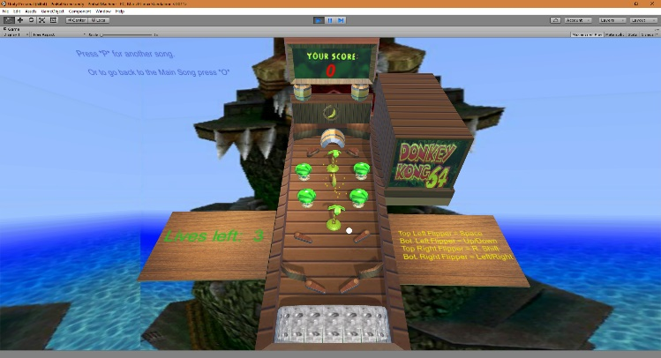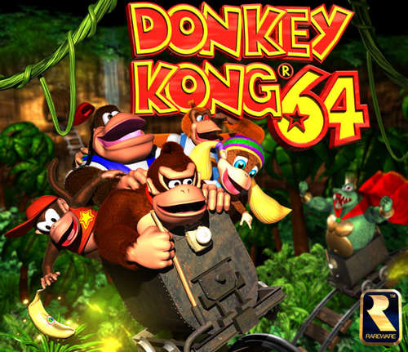

*General Objects and the overall visuals:*

*The aim i had in mind for the objects included in my pinball machine are that the objects shouldn’t be to complicated appearance wise and should stick to reasonably a low amount of polys to keep that old feeling to it. further more it should be quite flashy and colourful due to that the game its theme is from the 1990 era.*

*The placement of the objects didn’t have any reference of a pinball machine to it, its completely random, but its placed in a way that it doesn’t hinder the gamemechanics itself.*

*The references i used for my pinball machine its overall appearance are the following:*

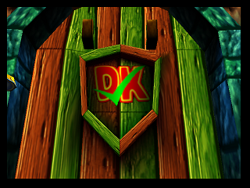*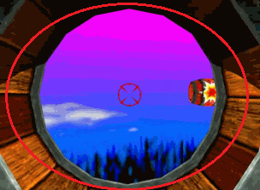The barrel outline is what i used as colour reference that it should be quite vibrant and strong, and not to high of an resolution.*

*Furthermore that it shouldn’t look realsitic or anything, and that it has to be low poly.*

*The reason why i went with this theme is because this is the first game i have ever played. And that this game is very dear to me because i played this with all my brothers and sisters back when i was only 5, and its one of the few games i really struggled with. I really had a good time playing it.*

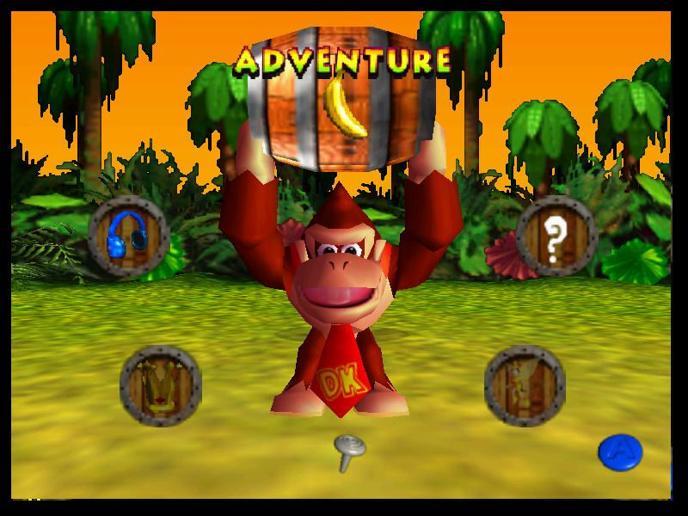*Here are a few more pictures of how the game looks like:*

: Menuscreen

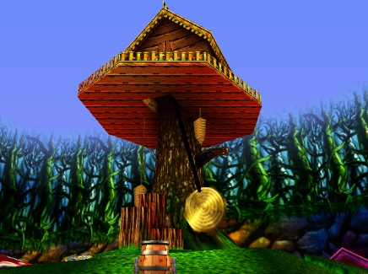

*: Mushroom Island (Chose this picture because most of the visuals that are represented here are included in the rest of the game.*

*ScoreBoard and the Background:*

*For the scoreboard i took the font that is included in the game itself and included that in photoshop and added a background with vines to it for a reference tot he game itself. After i adjusted it all in photoshop i compressed it to a JPG file and applied it to the scoreboard that is attached my pinball machine overall, as last i took a picture from donkey kong 64 where u see King K.Rools base and used that as background so it looks like that you are there while playing the gameitself.*